GIS Application

NCGSA Internship – week 5

8/8/22 | IST NAV App development | Mam Aneeqa

Kiran Sardar | 200901064

Syeda Farwa Rizvi | 200901098

# Literature Review

In the 5th week, we worked on the UI/UX implementation of a expo client app was the aim.

We also managed to add two pages, namely the Home page and Map page switching functionality to switch between the pages.

## UI/UX

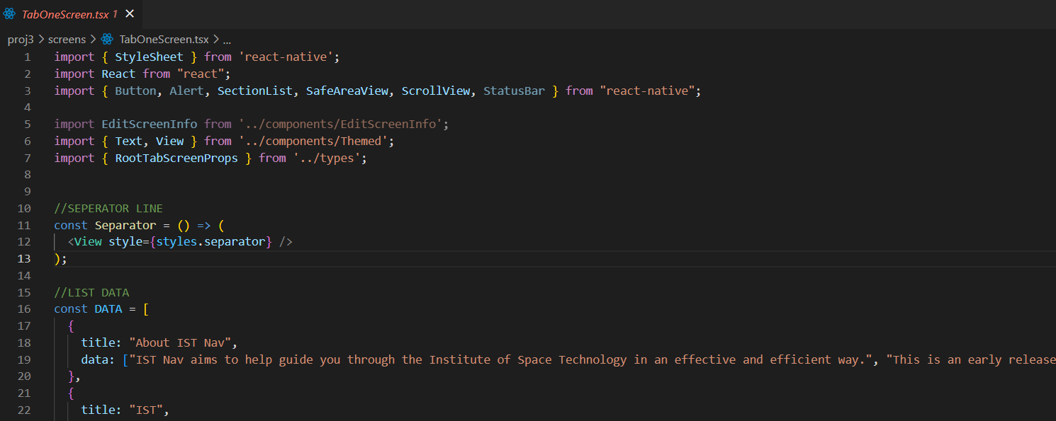

) backend of tab one

backend developed of tab one on TabOneScreen.tsx, this is a typescript file using multiple coding languages merged in one file so others regarding the ui will not need to be accessed.

#### Code:

import { StyleSheet } from 'react-native';

import React from "react";

import { Button, Alert, SectionList, SafeAreaView, ScrollView, StatusBar } from "react-native";

import EditScreenInfo from '../components/EditScreenInfo';

import { Text, View } from '../components/Themed';

import { RootTabScreenProps } from '../types';

//SEPERATOR LINE

const Separator = () => (

  <View style={styles.separator} />

);

//LIST DATA

const DATA = [

  {

    title: "About IST Nav",

    data: ["IST Nav aims to help guide you through the Institute of Space Technology in an effective and efficient way.", "This is an early release of the application and is yet to grow tremendously."]

  },

  {

    title: "IST",

    data: ["The Institute of Space Technology (also known as IST) (Urdu: ادارہ خلائی ٹیکنالوجی) is a public university located in Islamabad, Pakistan. It is focused on the study of astronomy, aerospace engineering and astronautics. [2]", "Established in 2002 under the auspices of the Pakistan National Space Agency. IST offers a wide array of undergraduate and graduate degrees in partnership of Beihang University and University of Surrey.[2] Since 2008, IST has an ISO certified management standard. IST is based on a 573 acre campus on the outskirts of Islamabad.[2][3] It is one of the top institutions as ranked by the Higher Education Commission.[4] Materials Inspection, Testing, and Characterization of Materials, a three-day workshop, was organised from March 8-10, 2022 at the Department of Materials Science and Engineering, (IST) Islamabad.[5]"]

  }

];

const Item = ({ title }) => (

  <View style={styles.item}>

    <Text style={styles.text}>{title}</Text>

  </View>

);

export default function TabOneScreen({ navigation }: RootTabScreenProps<'TabOne'>) {

  return (

    <View style={styles.container}>

      <SafeAreaView style={styles.container}>

    <ScrollView style={styles.scrollView}>

    <SectionList

      sections={DATA}

      keyExtractor={(item, index) => item + index}

      renderItem={({ item }) => <Item title={item} />}

      renderSectionHeader={({ section: { title } }) => (

        <Text style={styles.header}>{title}</Text>

      )}

    />

      <Separator />

    </ScrollView>

  </SafeAreaView>

    </View>

  );

}

const styles = StyleSheet.create({

  container: {

    flex: 1,

    alignItems: 'center',

    justifyContent: 'center',

  },

  title: {

    fontSize: 20,

    fontWeight: 'bold',

    marginTop: 16,

    fontFamily: 'space-mono'

  },

  separator: {

    marginVertical: 30,

    height: 1,

    width: '80%',

  },

  scrollView: {

    marginHorizontal: 2,

  },

  text: {

    fontSize: 20,

    color: 'white',

    fontStyle: 'normal',

    fontWeight: '100',

    fontFamily: 'space-mono'

  },

  fixToText: {

    flexDirection: 'row',

    justifyContent: 'space-evenly',

    overlayColor: 'rgba(255,255,255,0.05)',

  },

  header: {

    fontSize: 30,

    color: 'white'

  },

  item: {

      padding: 10,

      marginVertical: 2

    },

});

#### Output:

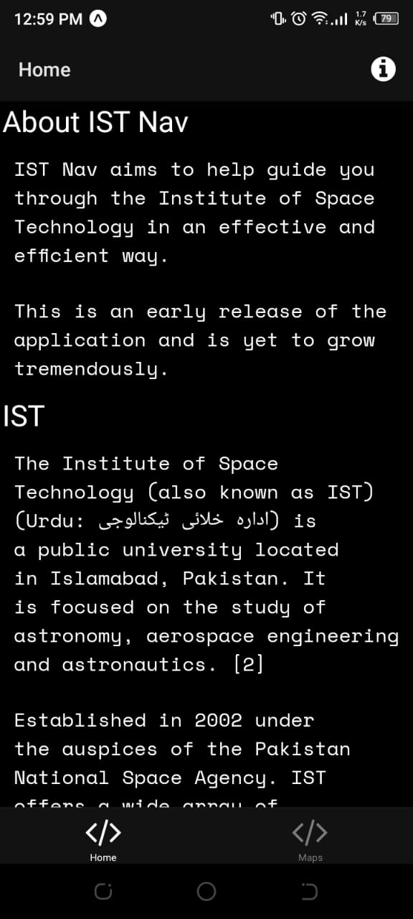Home Page UI developed

ii)Home Page Scrollable

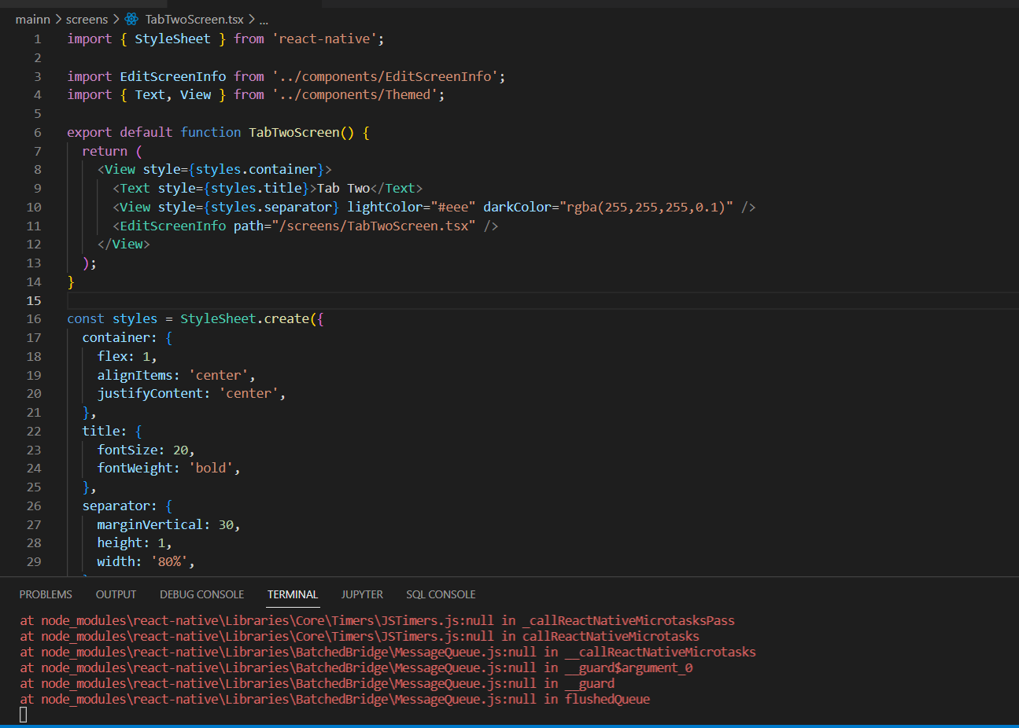

) Tab two code UI

#### Code:

import { StyleSheet } from 'react-native';

import EditScreenInfo from '../components/EditScreenInfo';

import { Text, View } from '../components/Themed';

export default function TabTwoScreen() {

  return (

    <View style={styles.container}>

      <Text style={styles.title}>Tab Two</Text>

      <View style={styles.separator} lightColor="#eee" darkColor="rgba(255,255,255,0.1)" />

      <EditScreenInfo path="/screens/TabTwoScreen.tsx" />

    </View>

  );

}

const styles = StyleSheet.create({

  container: {

    flex: 1,

    alignItems: 'center',

    justifyContent: 'center',

  },

  title: {

    fontSize: 20,

    fontWeight: 'bold',

  },

  separator: {

    marginVertical: 30,

    height: 1,

    width: '80%',

  },

});

)Template generated for map to be put

## Button finctionality

)Home page and Map page button functionality

#### Final app.tsx file code:

import { StatusBar } from 'expo-status-bar';

import { SafeAreaProvider } from 'react-native-safe-area-context';

import useCachedResources from './hooks/useCachedResources';

import useColorScheme from './hooks/useColorScheme';

import Navigation from './navigation';

export default function App() {

  const isLoadingComplete = useCachedResources();

  const colorScheme = useColorScheme();

  if (!isLoadingComplete) {

    return null;

  } else {

    return (

      <SafeAreaProvider>

        <Navigation colorScheme={colorScheme} />

        <StatusBar />

      </SafeAreaProvider>

    );

  }

}

### Navigational file (index.tsx)

/**

 * If you are not familiar with React Navigation, refer to the "Fundamentals" guide:

 * https://reactnavigation.org/docs/getting-started

 *

 */

import { FontAwesome } from '@expo/vector-icons';

import { createBottomTabNavigator } from '@react-navigation/bottom-tabs';

import { NavigationContainer, DefaultTheme, DarkTheme } from '@react-navigation/native';

import { createNativeStackNavigator } from '@react-navigation/native-stack';

import * as React from 'react';

import { ColorSchemeName, Pressable } from 'react-native';

import Colors from '../constants/Colors';

import useColorScheme from '../hooks/useColorScheme';

import ModalScreen from '../screens/ModalScreen';

import NotFoundScreen from '../screens/NotFoundScreen';

import TabOneScreen from '../screens/TabOneScreen';

import TabTwoScreen from '../screens/TabTwoScreen';

import { RootStackParamList, RootTabParamList, RootTabScreenProps } from '../types';

import LinkingConfiguration from './LinkingConfiguration';

export default function Navigation({ colorScheme }: { colorScheme: ColorSchemeName }) {

  return (

    <NavigationContainer

      linking={LinkingConfiguration}

      theme={colorScheme === 'dark' ? DarkTheme : DefaultTheme}>

      <RootNavigator />

    </NavigationContainer>

  );

}

/**

 * A root stack navigator is often used for displaying modals on top of all other content.

 * https://reactnavigation.org/docs/modal

 */

const Stack = createNativeStackNavigator<RootStackParamList>();

function RootNavigator() {

  return (

    <Stack.Navigator>

      <Stack.Screen name="Root" component={BottomTabNavigator} options={{ headerShown: false }} />

      <Stack.Screen name="NotFound" component={NotFoundScreen} options={{ title: 'Oops!' }} />

      <Stack.Group screenOptions={{ presentation: 'modal' }}>

        <Stack.Screen name="Modal" component={ModalScreen} />

      </Stack.Group>

    </Stack.Navigator>

  );

}

/**

 * A bottom tab navigator displays tab buttons on the bottom of the display to switch screens.

 * https://reactnavigation.org/docs/bottom-tab-navigator

 */

const BottomTab = createBottomTabNavigator<RootTabParamList>();

function BottomTabNavigator() {

  const colorScheme = useColorScheme();

  return (

    <BottomTab.Navigator

      initialRouteName="TabOne"

      screenOptions={{

        tabBarActiveTintColor: Colors[colorScheme].tint,

      }}>

      <BottomTab.Screen

        name="TabOne"

        component={TabOneScreen}

        options={({ navigation }: RootTabScreenProps<'TabOne'>) => ({

          title: 'Home',

          tabBarIcon: ({ color }) => <TabBarIcon name="code" color={color} />,

          headerRight: () => (

            <Pressable

              onPress={() => navigation.navigate('Modal')}

              style={({ pressed }) => ({

                opacity: pressed ? 0.5 : 1,

              })}>

              <FontAwesome

                name="info-circle"

                size={25}

                color={Colors[colorScheme].text}

                style={{ marginRight: 15 }}

              />

            </Pressable>

          ),

        })}

      />

      <BottomTab.Screen

        name="TabTwo"

        component={TabTwoScreen}

        options={{

          title: 'Maps',

          tabBarIcon: ({ color }) => <TabBarIcon name="code" color={color} />,

        }}

      />

    </BottomTab.Navigator>

  );

}

/**

 * You can explore the built-in icon families and icons on the web at https://icons.expo.fyi/

 */

function TabBarIcon(props: {

  name: React.ComponentProps<typeof FontAwesome>['name'];

  color: string;

}) {

  return <FontAwesome size={30} style={{ marginBottom: -3 }} {...props} />;

}

### Linking: (the multiple pages)

/**

 * Learn more about deep linking with React Navigation

 * https://reactnavigation.org/docs/deep-linking

 * https://reactnavigation.org/docs/configuring-links

 */

import { LinkingOptions } from '@react-navigation/native';

import * as Linking from 'expo-linking';

import { RootStackParamList } from '../types';

const linking: LinkingOptions<RootStackParamList> = {

  prefixes: [Linking.makeUrl('/')],

  config: {

    screens: {

      Root: {

        screens: {

          TabOne: {

            screens: {

              TabOneScreen: 'one',

            },

          },

          TabTwo: {

            screens: {

              TabTwoScreen: 'two',

            },

          },

        },

      },

      Modal: 'modal',

      NotFound: '*',

    },

  },

};

export default linking;